Case 5-Asia-China-Liangzhu-Cong square cylinder-Four-Tier-Jade-3300-2250 BCE
SHAPE \* MERGEFORMAT 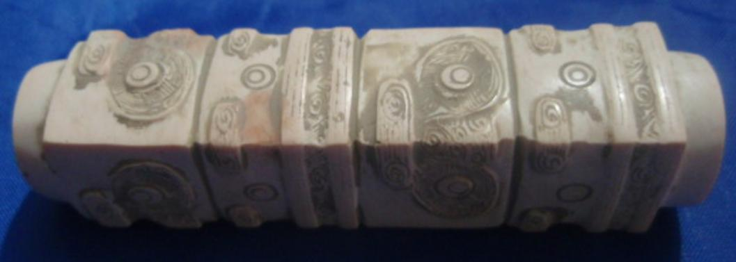 SHAPE \* MERGEFORMAT 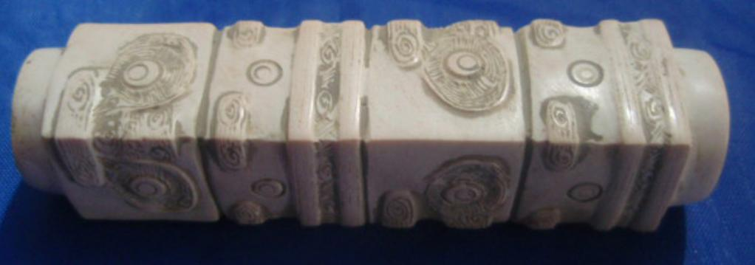

Figs. 1-2. China-Liangzhu-Cong square cylinder-Four-Tier-Jade-3300-2250 BCE
Accession Number:
Formal Label: A000-Asia-China-Liangzhu-Cong square cylinder-Four-Tier-Jade-3300-2250 BCE
Display Description:
White jade cong-shaped bead with four tiers of masks and with pink patches. A long tube with a square cross-section and a central perforation which has been drilled from both sides . There is a circular rim at each end. There are four tiers of two anthropomorphic masks and two animal masks, but one of the animal masks is turned at a right angle to the rest. The surface has a highly polished patina indicative of long use.
A comparable example is from Yaoshan that was excavated in June, 1987 (Lu Wenbao 1998: no. 54, pp. 98).
Liangzhu Congs are comprised of a square or nearly square exterior prism enclosing a circular inner column. The square represents Eh and the circular column represents Heaven. The color of the cong also hints at this symbolism. The late Zhou ritual classic, Zhou Li p, Chou Li wg (周禮) in the middle of the 2nd century BCE, compiled some three thousand years after the present example was manufactured, stipulated that "jade is used to make the six instruments by which the king worships Heaven and Earth and the four quarters [Spring, Summer, Autumn, Winter]. By the green bi (p), pi (wg) [round jade disk], heaven is worshipped; by the yellow cong (wg), tsung (p), Earth [is worshipped]" (Biot 1851). This cong may have been once more yellow, and its present creamy off-white color is thought to have been produced by minerals leaching from the decaying body into the nephrite during burial, a process that occurs in the first weeks after interment.

This four-tier cong has a narrow opening that is approximately 1/8 of the implement's outer diameter. The significance of this proportionality is unknown. According to Hayashi Minao, a Japanese expert of Liangzhu jades, two-tier congs are the earliest and were produced in the early Liangzhu period, ca. 3200 BCE, based on archaeologically excavated examples (Hayashi 1973; Hayashi 1990:6). In later Liangzhu phases congs were elongated with multiple tiers such as this one.. In the early Liangzhu period the central hole was characteristically wide, and as the congs were elongated the central holes, generally, were narrowed as in this one which places it probably in the mid-Liangzhu period, 2800 BCE.

The square exterior is comprised of double, repeated cartouche-like panels on each of the four corners. The upper panel is thought to represent an anthropomorphic mask, while the lower panel is thought to represent an animal mask. The juxtaposition of an animal and a human mask suggests that the human is in a shamanic relationship with an animal power. This iconography undoubtedly harkens back to a pre-Neolithic period when shamanic imagery was the symbolism of hunter-gatherers and was the imagery that was inscribed on petroglyph panels. Indeed, Hayashi Minao argues that the name of the cong/tsung derived from zhu/chu meaning "master" which we expand to "master of animal powers" (Hayashi 1990:6).

The interior of the column was believed to be the conduit for the communication with the numinous spirits that were depicted on its external surface.
As congs became more elongated the original paring of animal and anthropomorphic masks became obliterated, with only the human mask surviving. At the end point of this trend the mask became mere ridges that no longer had even an abstract likeness to a human mask. Finally, the cong was no longer made of jade the divine substance but of wood. Its secularization was complete.
The evolution of the cong mask, therefore, appears to have undergone a transformation from that of a shamanic device of invoking animal powers to that of purely human ancestral powers by eliminating the animal panels to that of a series of purely abstract ridges suggesting a semiological transformation as well: from symbolizing the numinous power of shamanic elders to symbolizing the numinous power of ancestors to symbolizing the historical succession of generations purely abstractly.

LC Classification: NK5750.2.A1
Date or Time Horizon: Liangzhu culture, lower Yangzi River Valley, early Liangzhu Period, ca. 3200 BCE Geographical Area: Liangzhu culture, lower Yangzi River Valley
Map:
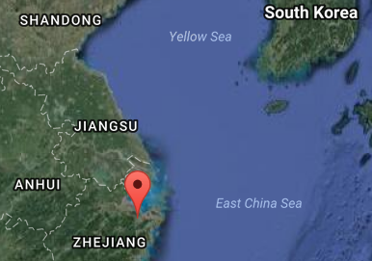
Fig. 3. Location of Liangzhu site proper. Source: Google Earth

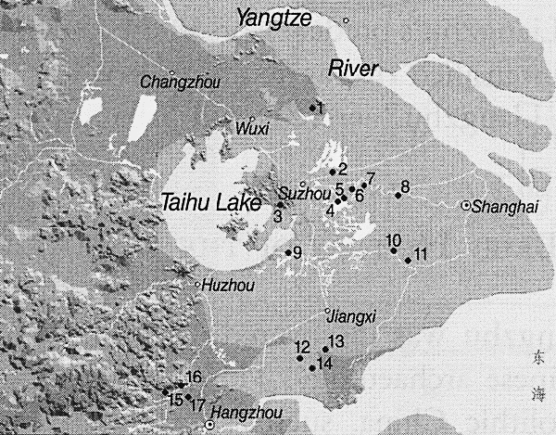
Fig. 4. Detail of Liangzhu site complex surrounding Taihu. After Zhou Ying 2007.

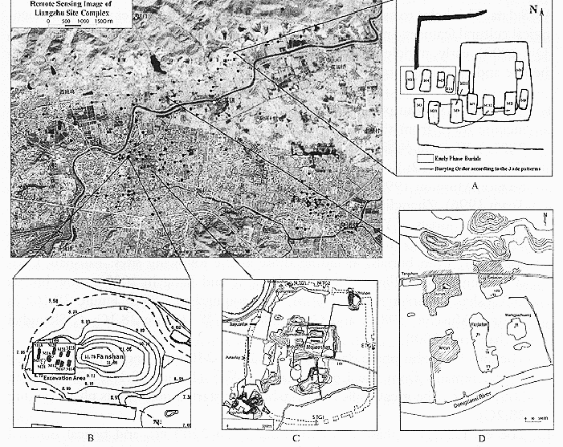
Fig. 5. Detail of Liangzhu site proper. After Zhou Ying 2007.

GPS coordinates:
Northeast corner: N 30°24'48", E 120°00'17"
Northwest corner: N 30°24'41", E 119°58'58"
Southeast corner: N 30°23'20", E 120 00'19"
Southwest corner: N 30°22'55", E 119°58'28"

Cultural Affiliation: Liangzhu culture, lower Yangzi River Valley, 3300-2250 BCE
Medium: Jade
Cultural Affiliation: Liangzhu
Medium: jade
Dimensions: H 2.375, W 3.25 in., D 3.25 in., hole Dia 2.5 in.,
Weight: 425 gm.
Condition: original
Provenance:
Discussion:
Liangzhu (3400–2250 BCE) in Yuhang County, Zhejiang, was a highly stratified Neolithic jade city-state in the Yangtze River delta where élites controlled a sphere of influence north to Shanxi and south to Guangdong.
DNA recovered from Liangzhu graves shows high frequencies of Haplogroup O1 linking it with modern Austronesians.
The use of jade and other expensive wares (such as silk, lacquerware, and ivory) in grave sites characterized the social symbolism of Liangzhu élites. About 4200 BP Liangzhu succumbed to a series extreme floods since the cultural layers are interrupted by intrusions of mud and sand. It is also possible that an asteroid created Taihu lake 4500 BP, which contributed to its demise.

References:
Biot, Jean Baptiste. 1851. Le Tcheou-li: ou, Rites des Tcheou. Paris: Imprimerie nationale, 1851. 3v.

Chang, K.C., Xu, P. and Lu, L. 2005. The formation of Chinese civilization: an archaeological perspective. New Haven: Yale University Press.

Hayashi, Mineo. 1990. On the Chinese Neolithic jade Tsung/Cong, Artibus Asiae, 50(1/2):5-22.

Hayashi, Mineo. 1973. Toyo Gakuho [Journal of the Research Dept. of the Toyo Bunko] 45:1-57.

Hayashi, Minao. 林巳奈夫. 1991. Chūgoku kogyoku no kenkyū. 中國古玉の研究. Tōkyō : Yoshikawa Kōbunkan; 東京 : 吉川弘文館, 1991

Li, Hui; Huang, Ying; Mustavich, Laura F.; Zhang, Fan; Tan, Jing-Ze; Wang, ling-E; Qian, Ji; Gao, Meng-He; Jin, Li. 2007. "Y chromosomes of prehistoric people along the Yangtze River," Human Genetics 122: 383–388.

Lu Wenbao. 1998. Cong-shaped bead. In Liangzhu Culture Museum, ed., The dawn of Chinese civilization: Jades of the Liangzhu culture. Hong Kong: Liangzhu Culture Museum and The Art Museum, The Chinese University of Hong Kong

Wu, Li. 2014. "Holocene environmental change and its impacts on human settlement in the Shanghai Area, East China," Catena. 114: 78–89

Zhang, Chia; Hsiao-Chun, Hung. 2008. "The Neolithic of Southern China–Origin, Development, and Dispersal,"Asian Perspectives. 47:2, 309–310.

Zhou Ying. 2007. "The Dawn of the Oriental Civilization: Liangzhu site and Liangzhu culture. Beijing: China Intercontinental Press.

